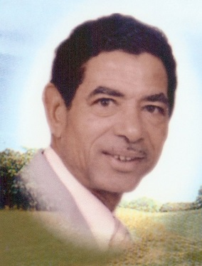

Sponsor/Contributor Form

Saturday, June 1, 2024

LinRick Golf Course
356 Camp Ground Road
Columbia, SC 29203
(803) 754-6331

$100 Sponsorship (please provide a business card or name for memorial)
Business or Memorial name will be prominently displayed on one of 18 greens or tee boxes
$ 75 Contribution to sponsor a player:
(Player’s name or write “anyone”)
$ Donation: Your contribution is greatly appreciated.
Business Name or
Donor’s Name or
In Memory Of:
Contact PErson or
Sponsor’s Name:
Phone Number:
Address:
email:

Thank You For Your Support!

